**ASSIGNMENT 25.5**

**CREATE DATABASE,TABLE AND LOAD**

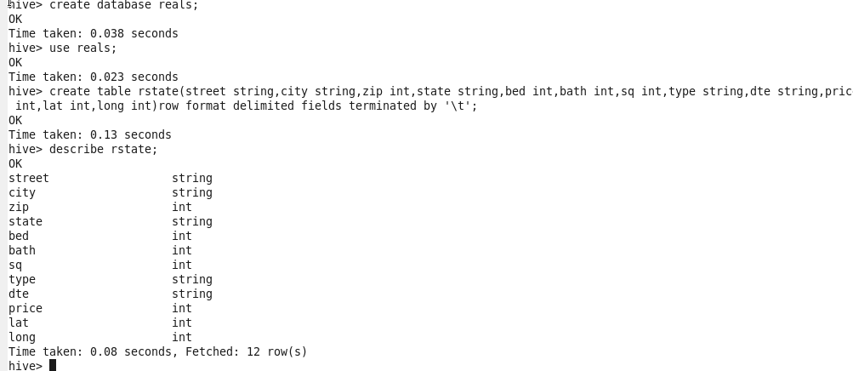

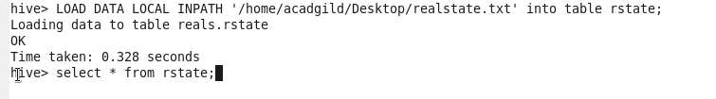

**1. Write a hive query to list top 5 residency details which lie in the budget of 60000-120000, an area more than 1450, sold after 17th may, min bedroom 3 and, min bathroom 2**



**OUTPUT**

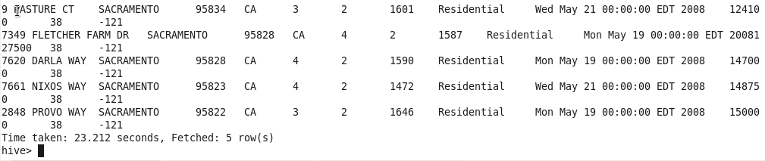

**2. Write a hive query to separate list of residential apartments with more than 2 beds. Also include columns in following order City,Baths,Sq_feet,Price,flat_type,Beds respectively.**







**OUTPUT**

